St Fillan’s Primary School and Nursery Class

Parent Council Constitution
  - Name
    - This is the constitution of the Parent Council (the “Constitution”).
    - The Parent Council shall be known as “St Fillan’s Parent Council”.
  - Objectives
    - The objectives of the Parent Council are:
      - to work in partnership with the School to create a welcoming, inclusive community for all pupils, staff, parents and carers;
      - to promote partnership between the School, its pupils, parents, carers, the Roman Catholic Church and the wider community;
      - to develop and engage in activities which support the education and welfare of all School pupils;
      - to identify and represent the views of Parents/ Carers on matters affecting the education and welfare of School pupils;
      - to promote equality of opportunity and embrace diversity in all School activities;
      - to represent Parent/ Carer views to the local authority and to the School leadership;
      - to carry out fundraising activities for the benefit of the School and its pupils;
      - to apply for and receive grants, gifts, donations, or legacies, subject to any reasonable conditions attached to them;
      - to donate funds to the School for use as agreed by the Parent Council;
      - to carry out the functions of the former Parent Teacher Association (“PTA”) and to receive and manage all PTA funds transferred to the Parent Council; and
      - to use all funds received or raised from time to time solely for the benefit of the School.
  - Membership
    - The Parent Council will consist of up to ten (10) Parent/Carer members, selected in accordance with section ‎4 (Selection of Members) (each a “Parent/Carer Member”).
    - In addition, the Council may co-opt up to five 5 Members who are not Parent/Carers, provided that:
      - at least one will be a teaching staff representative;
      - at least one will be a church representative; and
      - up to three additional co-opted Members may be invited from the wider community or for their expertise,

each being a “Co-Opted Member”.
    - The head teacher of the School (or their representative) has the right and duty to attend all Parent Council meetings but shall not be a Member.
    - The quorum for meetings will be five (5) Members, of whom at least three (3) must be Parent/ Carer Members.
    - Where possible, Parent/ Carer membership will represent the different stages of the School (nursery, lower school, and upper school).
  - Selection of Members
    - Members will be elected for a period of one (1) year at the AGM.
    - Any Parent/Carer of a child at the School may volunteer to be a Member.
    - If the number of volunteers exceeds available places, Members will be chosen by drawing names in the presence of the nominees and a quorum of the Parent Council.
    - A Parent/ Carer not selected to be a Member may be placed on a reserve list or invited by the Parent Council to join sub-groups established by the Parent Council.
    - Members may resign:
      - at any time by written notice to the Chair; or
      - by tendering their resignation at a Parent Council meeting.
    - If at any time the number of Parent/ Carer Members falls below ten (10) the Parent Council may select replacement Members at the next Parent Council meeting in accordance with the process set out in this section ‎4 and such Members shall serve until the next AGM after their selection.
    - Each Parent/ Carer Member shall automatically cease to be a Member when they no longer have a child attending the School (with effect from the AGM in the school year in which their child leaves the School).
  - Office Bearers
    - At the first Parent Council meeting after each AGM, the Parent Council will appoint :
      - a chair (the “Chair”);
      - a vice chair (to deputise for the Chair when they are unavailable);
      - a treasurer (the “Treasurer”),

each an “Office Bearer”.
    - Each Office Bearer must be a Parent/ Carer Member.
    - Office Bearers will serve for one (1) year but may stand for re-election. If an Office Bearer resigns or otherwise leaves their role a replacement will be appointed at the next meeting of the Parent Council.
    - The Parent Council may appoint a clerk to the Parent Council to assist with the administrative business of the Parent Council (and which may be a shared role and need not be a Member).
  - Meetings
    - The Parent Council will meet at least once per School term, and more often if required.
    - The Parent Council will hold an annual general meeting each year in May, with at least fourteen (14) days’ notice to all members of the Parent Forum (the “AGM”).
    - The business of the AGM will include:
      - reports on the work of the Parent Council and its committees;
      - a report from the Head Teacher;
      - selection of new Members; and
      - approval of accounts.
    - Any two (2) Parent Council Members may request an additional meeting, giving at least fourteen (14) days’ notice (a “Special General Meeting”).
    - All Parent/ Carers are welcome to attend and contribute to Parent Council meetings. The Parent Council will seek to make all decision by consensus of Members. If consensus is not reached votes will be decided by simple majority of Members. Subject to section ‎‎11.2, only Members may vote on Parent Council business. In the event of a tied vote, the Chair will have a casting vote.
  - Conduct
    - Members are expected to show respect and uphold the objectives of the Parent Council.
    - At or following their selection and/or induction each Member shall be provided with a copy of such policies and procedures as the Parent Council may stipulate from time to time (which may include GDPR, complaints and social media policies) (the “PC Policies”) and may be required to sign the PC Policies to confirm their agreement.
    - A Member who:
      - acts in a way that undermines the objectives of the Parent Council; or
      - breaches the PC Policies,

may be removed by majority vote of the Parent Council.
    - Members should attend at least fifty percent (50%) of meetings/events in each year unless reasonable explanation is given.
  - Minutes and Confidentiality
    - Minutes will be made available to all Parents/ Carers and staff by being published on the school website, shared via the School newsletter and/or being made available from the school office.
    - Parent Council Meetings are open to all Parent/ Carers, except where confidential matters are discussed (as determined by the Chair).
    - Issues relating to individual pupils, Parent/ Carers, or staff are not within the Parent Council’s remit.
  - Finance
    - All funds will be held in a bank account in the name of St Fillan’s Parent Council.
    - The bank account will have at least three authorised signatories (Chair, Treasurer, and one other Parent/ Carer Member).
    - The Treasurer will keep accurate records and provide reports at each meeting and a full account at the AGM.
    - Accounts will be examined annually by an independent examiner appointed at the AGM.
    - All monies will be used solely in accordance with the objectives of the Parent Council.
  - Sub-Groups
    - The Parent Council may set up sub-groups (e.g. fundraising committees) for specific purposes.
    - Sub-groups must operate under the authority of the Parent Council and report back regularly.
    - Members of sub-groups may include Parent Council Members and/or volunteers approved by the Council.
    - Sub-groups shall be entitled to organise their business as their members see fit (including as to frequency of meetings and decision-making) provided that they act at all times in accordance with the objectives of the Parent Council.
  - Changes to the Constitution
    - Members of the Parent Forum must be given at least thirty (30) days’ notice of proposed amendments to the Constitution (via the School website and/or the School weekly newsletter and/or another suitable communication method) and be given the opportunity to respond indicating whether or not they consent or do not consent to such amendments.
    - The Constitution may be changed at an AGM or a Special General Meeting, with the approval of a majority of the total of:
      - those Parent/ Carers present; and
      - those Parent/ Carers who have responded in writing pursuant to section ‎11.1.
    - Each Member of the Parent Forum shall be entitled to attend each AGM or Special General Meeting at which a change to the Constitution is tabled.
  - Dissolution
    - If the Parent Council ceases to exist, any remaining funds will be transferred to the local authority for the benefit of the School (or if the School ceases to exist, for the benefit of education in the area).
  - Definitions
    - In this Constitution the following terms have the following meanings:
      - “AGM” has the meaning given in section ‎6.2;
      - “Chair” has the meaning given in section ‎5.1.1
      - “Constitution” has the meaning given in section ‎1.1;
      - “Co-Opted Member” has the meaning given in section ‎3.2;
      - “Member” means each Parent/ Carer Member and each Co-Opted Member;
      - “Office Bearer” has the meaning given in section ‎5.1;
      - “Parent/Carer” means a parent or carer of a child who is a pupil at the School, including non-resident parents with parental responsibilities, foster carers, guardians and others caring for children under supervision arrangements;
      - “Parent/ Carer Member” has the meaning given in section ‎‎3.1;
      - “Parent Forum” means all Parents/Carers of children who are pupils at the School;
      - “Parent Council” means the group constituted under this constitution to represent the Parent Forum, being a parent council under the Scottish Schools (Parental Involvement) Act 2006;
      - “PC Policies” has the meaning given in section ‎7.2;
      - “PTA” has the meaning given in section ‎2.1.10;
      - “School” means St Fillan’s Primary School and Nursery Class, 20 Crompton Avenue, Glasgow G44 5AF;
      - “Special General Meeting” has the meaning given in section ‎6.4; and
      - “Treasurer” has the meaning given in section ‎5.1.3.
Adopted 26/11/25
Signed: 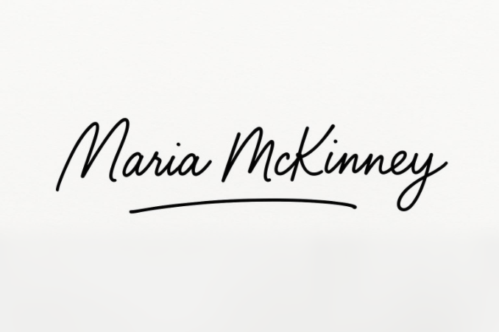 (Chair)

Signed: (Head Teacher)

